# hypergeometric distribution

Def

PDF

$$f\left(k;N,K,n\right)$$

= $$\frac{C\left(k,K\right)}{C\left(n,N\right)}⋅C\left(n−k,N−K\right)$$

where

$$C\left(n,N\right)$$

= $${}_{N}C_{n}$$

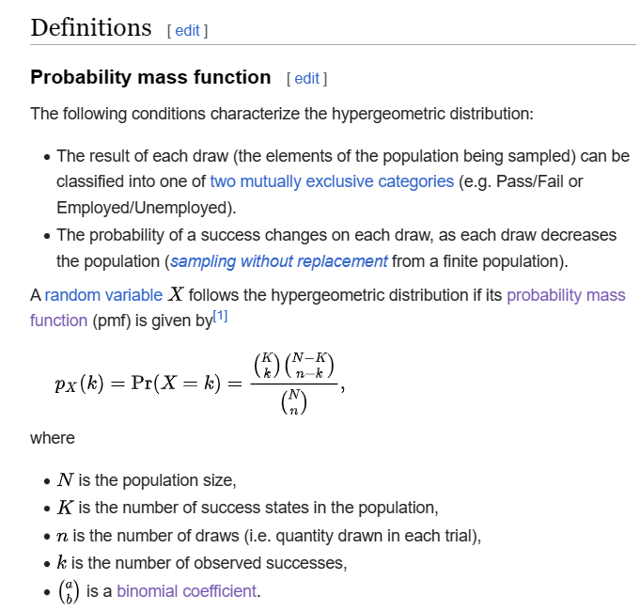

CDF

Expected Value

Variance

Property

Symmetry

$$f\left(k;N,k,n\right)$$ = $$f\left(n−k;N,N−K,n\right)$$

$$f\left(k;N,K,n\right)$$ = $$f\left(K−k;N,K,N−n\right)$$

$$f\left(k;N,K,n\right)$$ = $$f\left(k;N,n,K\right)$$

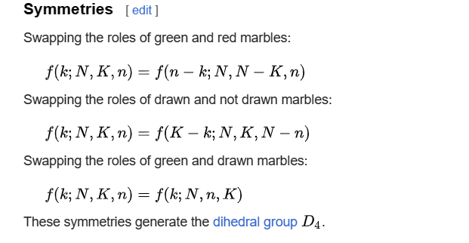

Ref

[Hypergeometric distribution - Wikipedia](https://en.wikipedia.org/wiki/Hypergeometric_distribution)

# 

# 